# SAP Lumira Hands-on Workshop APPENDIX

|  |  |
| --- | --- |
| Scenario | Generate an SVG file for use in Lumira as a Pictogram |

From your browser, navigate to <http://flamingtext.com/imagebot/editor>

You should see the Quick Start dialog box.

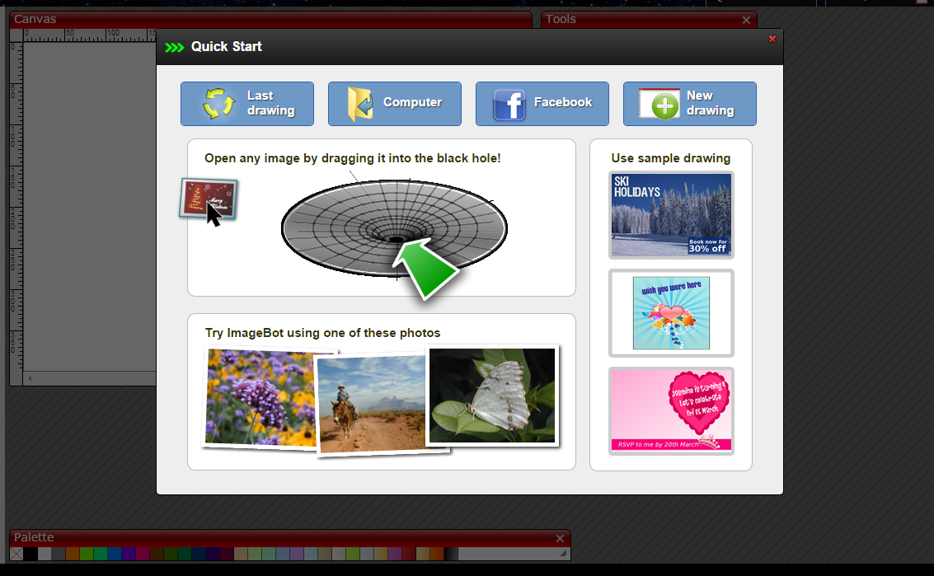

Simply drag and drop a typical image (jpg, png, and others) as directed

If you closed the Quick Start dialog, you should see a tab for it. Or just use the File Menu and choose **File -> Open** to select your graphic.

Once the graphic is on the canvas, use the File Menu to edit the SVG source. **Go View -> SVG Source**

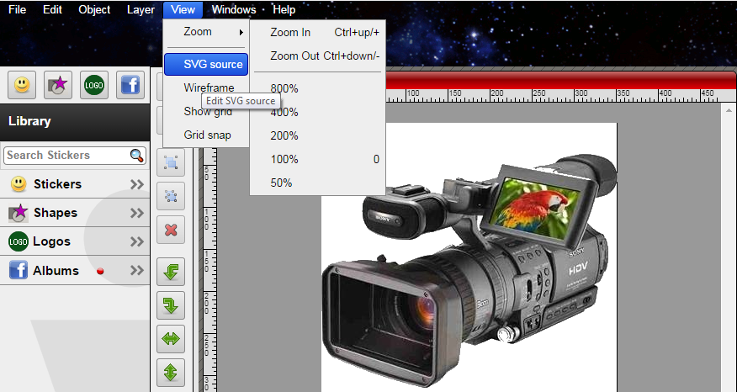

Once selected, you should see a code window similar to

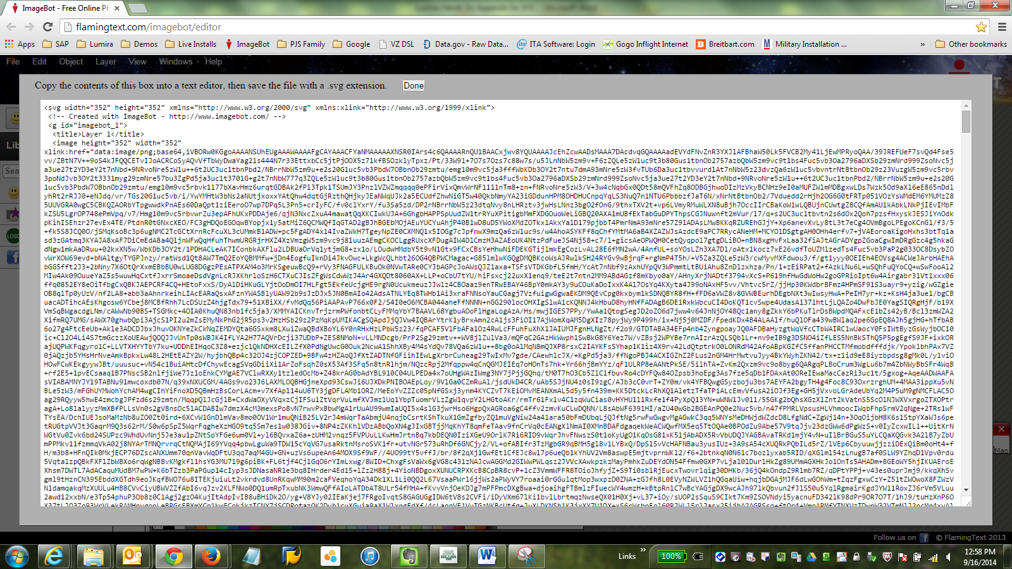

Select all within the window and copy to clipboard (**Ctrl-A** then **Ctrl-C**)

Next open up Notepad or similar text editor

Paste the code into the editor and save the file with SVG as an extension. Camera.svg for example. In the Lumira interface, import this file into the **Pictogram** picker.